

Lab - Create User Accounts

Introduction

In this lab, you will create and modify user accounts in Windows. Part 1: Creating a New Local User Account Part 2: Reviewing User Account Properties Part 3: Modifying Local User Accounts

Required Resources

A Windows PC

Part 1: Creating a New Local User Account

Step 1: Open the User Account Tool.

- Log on to the computer with an Administrator account. The account CyberOpsUser is used in this example.

- Click Start > search Control Panel. Select User Accounts in the Small icons view. To change the view, select Small icons in the View by drop down list.
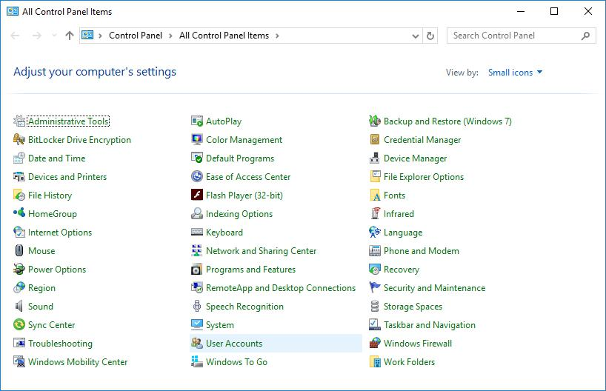

Cisco and/or its affiliates. All rights reserved. Cisco Confidential Page 1 of 9 www.netacad.com
Lab - Create User Accounts

Step 2: Create a user account.

- The User Accounts window opens. Click Manage another account.
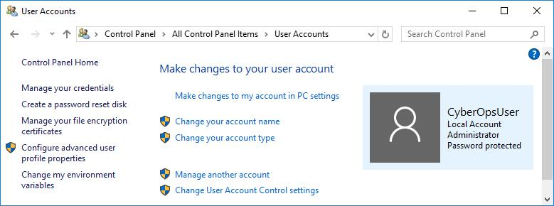

- The Manage Accounts window opens. Click Add a new user in PC settings.
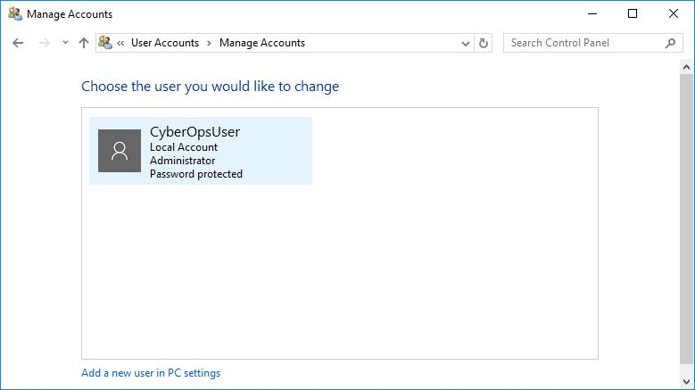

Cisco and/or its affiliates. All rights reserved. Cisco Confidential Page 2 of 9 www.netacad.com

Lab - Create User Accounts

- The Settings window opens. Click Add someone else to this PC.
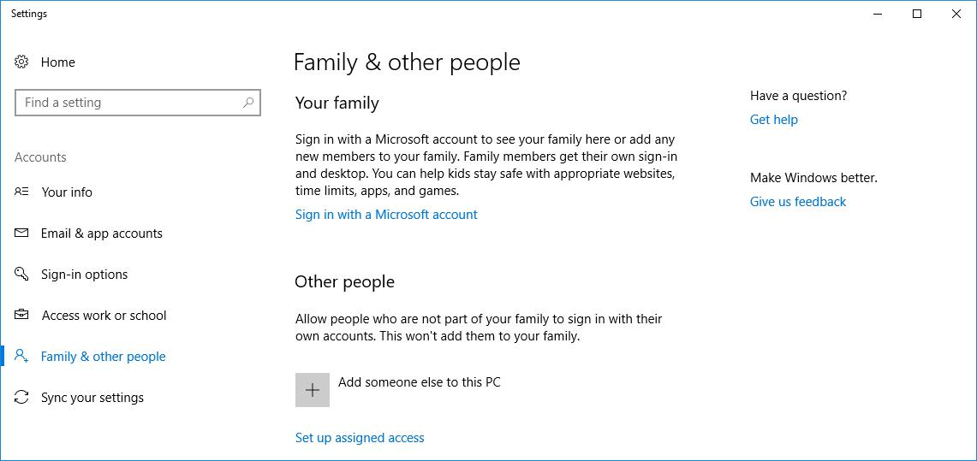

- The How will this person sign in? window opens. Click I don't have this person's sign-in information.
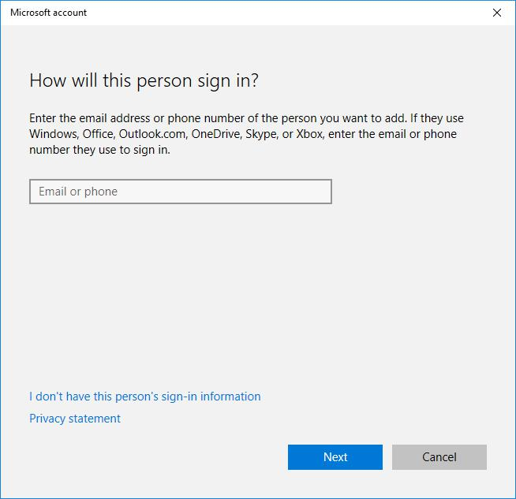

Cisco and/or its affiliates. All rights reserved. Cisco Confidential Page 3 of 9 www.netacad.com

Lab - Create User Accounts

- The Let's create your account window opens. Click Add a user without a Microsoft account.
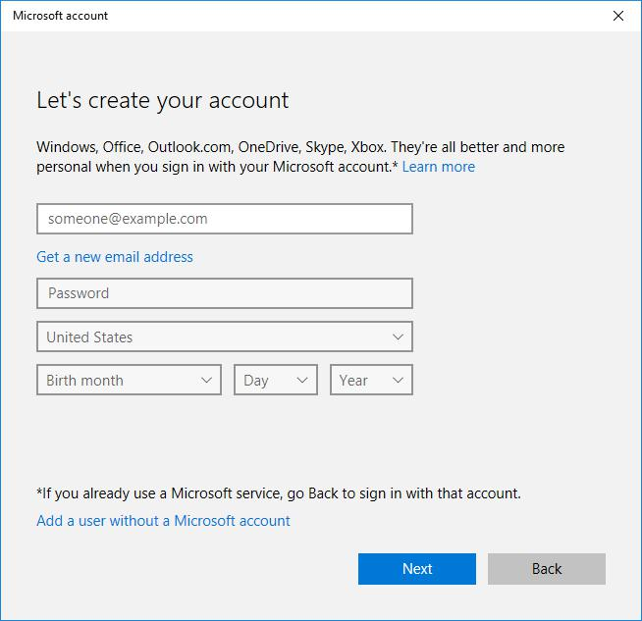

Cisco and/or its affiliates. All rights reserved. Cisco Confidential Page 4 of 9 www.netacad.com

Lab - Create User Accounts

- The Create an account for this PC window opens. Provide the necessary information to create the new user account named User1. Click Next to create the new user account.
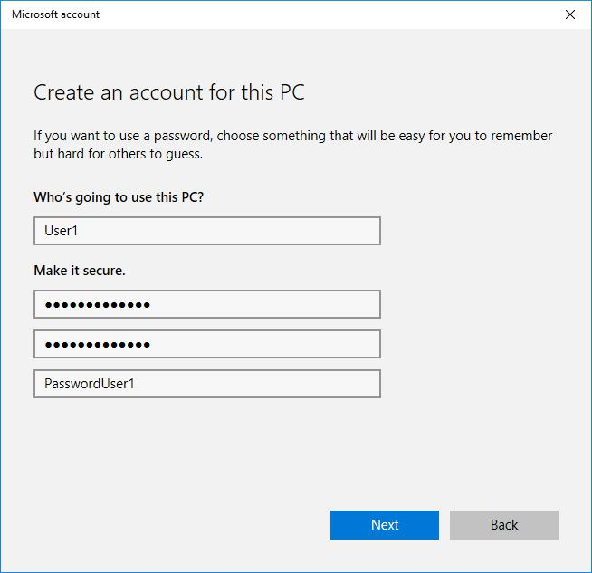

- What type of user account did you just create?

_______________локальний обліковий запис______________________________

- Log into the newly created user account. It should be successful.

- Navigate to C:\Users folder. Right-click the User1 folder and select Properties, and then the Security tab. Which groups or users have full control of this folder?

____System, User1, Administrator_______________________

- Open the folder that belongs to CyberOpsUser. Right-click the folder and click the Properties tab. Were you able to access the folder? Explain.
Локальні об.записи не можуть мати доступу до цієї папки

- Log out of User1 account. Log back in as CyberOpsUser.

- Navigate to C:\Users folder. Right-click the folder and select Properties. Click the Security tab. Which groups or users have full control of this folder?

неможливо переглянути, але повний доступ точно має Адміністратор_________________

Cisco and/or its affiliates. All rights reserved. Cisco Confidential Page 5 of 9 www.netacad.com

Lab - Create User Accounts

Part 2: Reviewing User Account Properties

- Click Start > Search for Control Panel > Select Administrative Tools > Select Computer Management.

- Select Local Users and Groups. Click the Users folder.
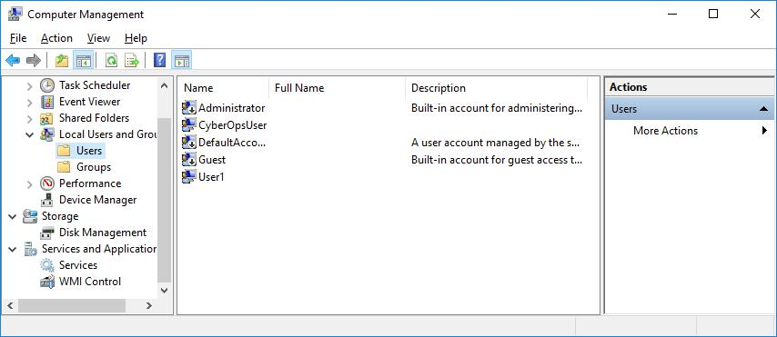

- Right-click User1 and select Properties.

- Click the Member Of tab.
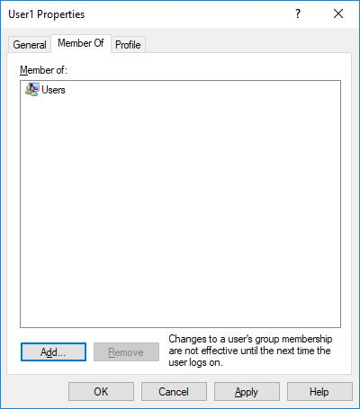

Which group is User1 is a member of? _____Користувачі___________________

- Right-click the account CyberOpsUser and select Properties.

Which group is this user a member of? ____Адміністратори_____________

Cisco and/or its affiliates. All rights reserved. Cisco Confidential Page 6 of 9 www.netacad.com

Lab - Create User Accounts

Part 3: Modifying Local User Accounts

Step 1: Change the account type.

- Navigate to the Control Panel and select User Accounts. Click Manage another account. Select User1.
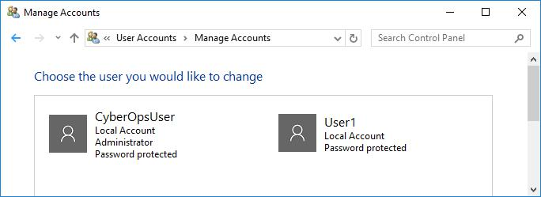

b. In the Change an Account window, click the User1 account. Click Change the account type.
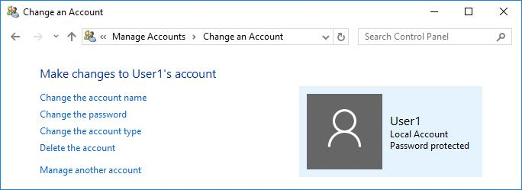

- Select the Administrator radio button. Click Change Account Type.
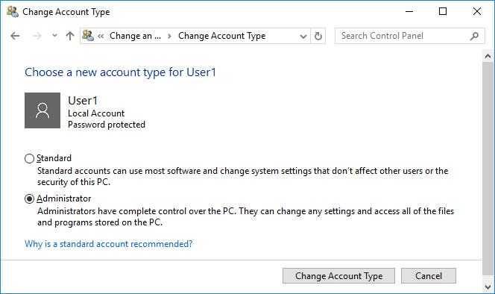

Cisco and/or its affiliates. All rights reserved. Cisco Confidential Page 7 of 9 www.netacad.com

Lab - Create User Accounts

- Now the account User1 has administrative rights.

- Navigate to Control Panel > Administrative Tools > Computer Management. Click Local Users and Groups> Users.

- Right-click User1 and select Properties. Click Member Of tab. Which groups does User1 belong to?
_____Адміністратори та Користувачі_________________________________

- Select Administrators and click Remove to remove User1 from the Administrative group. Click OK to continue.
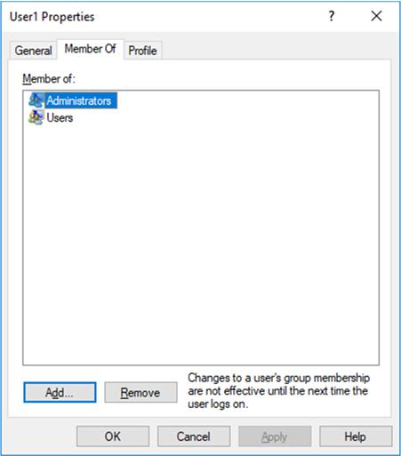

Step 2: Delete the account.

a. To delete the account, right-click User1and select Delete.
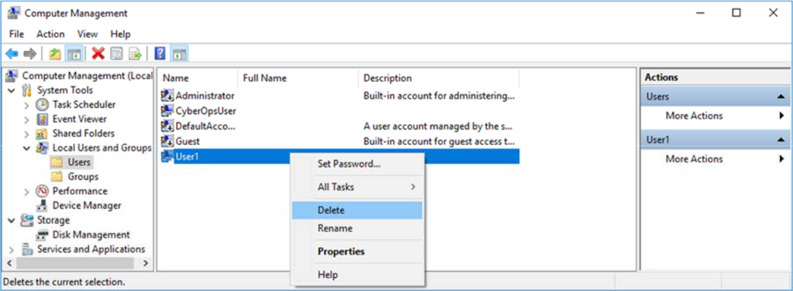

- Click OK to confirm the deletion. What is another way to delete a user account?

_______Панель керування → керування обліковими записами → User1 →Видалити_________

Cisco and/or its affiliates. All rights reserved. Cisco Confidential Page 8 of 9 www.netacad.com

Lab - Create User Accounts

Reflection

- Why is it important to protect all accounts with strong passwords?
Щоб зловмисник не міг получити доступ навіть до тих файлів, до яких є доступ у користувача з найменшим рівнем доступу, адже навіть так зловмисник може завдати шкоди системі чи викрасти дані

- Why would you create a user with Standard privileges?

Краще не надавати користувачу прав адміністратора, адже тоді хакер, що отримає доступ до вашого запису, буде мати абсолютний контроль над усім вашим комп’ютером

Cisco and/or its affiliates. All rights reserved. Cisco Confidential Page 9 of 9 www.netacad.com

